

SULTAN KUDARAT STATE UNIVERSITY
COLLEGE OF COMPUTER STUDIES
Isulan Campus, Isulan, Sultan Kudarat

CC115 – Information Management
Midterm Examination
March 15-17, 2023

Name: ________________________________________ Crs. /Yr. /Section: ______ Score: _____

General Instructions:
Avoid cheating. Avoid erasure. Write your answer legibly.

- True or False. Write T if the statement is true, else F if the statement is false on the space provided before each number. (One point each).
_______ | 1. | A modern- day database is a structured collection of data stored in a computer.
_______ | 2. | E. F. Codd propose the revolutionary relational data model.
_______ | 3. | Microsoft Access, IBM DB2, Oracle, Sequel Server and MySQL are examples of DBMS.
_______ | 4. | File processing system is a precursor of the integrated database approach.
_______ | 5. | Duplication of data creates problems with data integrity.
_______ | 6. | Database is a large repository of data that can be used simultaneously.
_______ | 7. | A set of sophisticated programs known as a DBMS is use store, access, and manipulate the data in the database.
_______ | 8. | Database is also known as logically related.
_______ | 9. | Entities, attributes and relationships based on the perception of the real world.
_______ | 10. | Database is a shared collection of logically related data.

II. Multiple Choice: Encircle the letter of the correct answer. (Two points each)
11. | What do you call to the data object, either real or abstract that we want to collect for information?
 | - Entities | - Relationships | - Attributes | - Relationship Set
12. | What do you call to the natural associations between entities?
 | - Entities | - Relationships | - Attributes | - Relationship Set
13. | What do you call to the entities properties or values?
 | - Entities | - Relationships | - Attributes | - Relationship Set
14. | What do you call to a table with columns and rows?
 | - Tuple | - Attribute | - Domain | - Relation
15. | What do you call to a named column in relation?
 | - Tuple | - Attribute | - Domain | - Relation
16. | What do you call to a set of allowable values for one or attributes?
 | - Tuple | - Attribute | - Domain | - Relation
17. | What do you call to the row of the relation?
 | - Tuple | - Attribute | - Domain | - Relation
18. | What do you call to a self-describing collection of integrated records.?
 | - File | - Data | - Column | - Database
19. | What database language that allow users to define the database?
 | - DML | - DDL | - DHL | - LHD
20. | What database language that allow users to insert, update, delete, and retrieve data from the database?
 | - DML | - DDL | - DHL | - LHD
21. | What do you call to a SQL statement used to insert new records in a table?
 | - Select | - Insert | - Update | - Delete
22. | What do you call to a SQL statement used to modify the existing records in a table?
 | - Select | - Insert | - Update | - Delete
23. | What do you call to a SQL statement used to delete existing records in a table?
 | - Select | - Insert | - Update | - Delete
24. | What do you call to a SQL statement used to select data from a database?
 | - Select | - Insert | - Update | - Delete
25. | What do you call to a constraint that uniquely identifies each record in a table?
 | - Candidate key | - Primary key | - Foreign key | - General key
26. | What do you call to a constraint used to prevent actions that would destroy links between tables?
 | - Joins | - Inner join | - Outer join | - Self join

- Identification: Identify the following parts of the relation. (Two points each)
 | 27. | ____________________ | 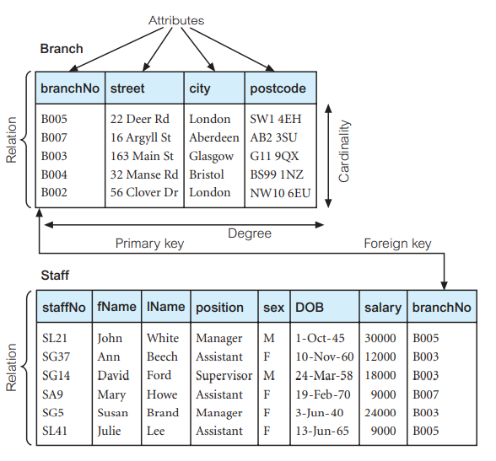  26  25  24  23  21
 | 28. | ____________________
 | 29. | ____________________
 | 30. | ____________________  22
 | 31. | ____________________
 | 32. | ____________________
 | 33. | ____________________
 |  | 27

- Essay: Discuss each given questions. Write your answers legibly. (5 points each)

- Differentiate primary key to foreign key.


Prepared by:

CYRUS B. RAEL, MIT
Instructor

Reviewed by:

CYRUS B. RAEL, MIT
Chairman, BS in Computer Science

Approved by:

ELBREN O. ANTONIO, DIT
Dean, College of Computer Studies

